**LM358 TEMPERATURE SENSOR**

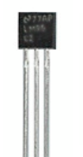

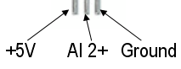



LM35 is a precision IC temperature sensor with its output proportional to the temperature (in **o**C). The sensor circuitry is sealed and therefore it is not subjected to oxidation and other processes. With LM35, temperature can be measured more accurately than with a thermistor. It also possess low self heating and does not cause more than 0.1 **o**C temperature rise in still air.

  The operating temperature range is from -55°C to 150°C. The output voltage varies by 10mV in response to every **o**C rise/fall in ambient temperature, *i.e.,* its scale factor is 0.01V/ **o**C.

**Pin Diagram:**

